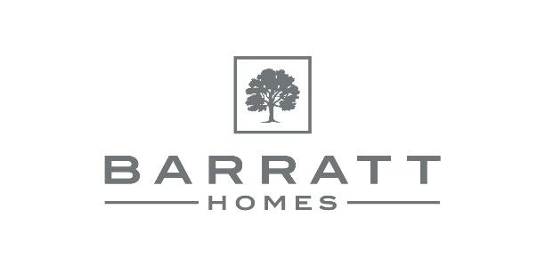
Date: 24.08.20
MAKE THE MOST OF SUMMER 2020 WITH LEADING DEVELOPER’S TOP TIPS FOR A STAYCATION
For immediate release
As a nation, Britons love a summer holiday abroad, in the sunshine, by the sea. However, as a result of the Coronavirus pandemic, holidaying abroad may not be an option for many people.
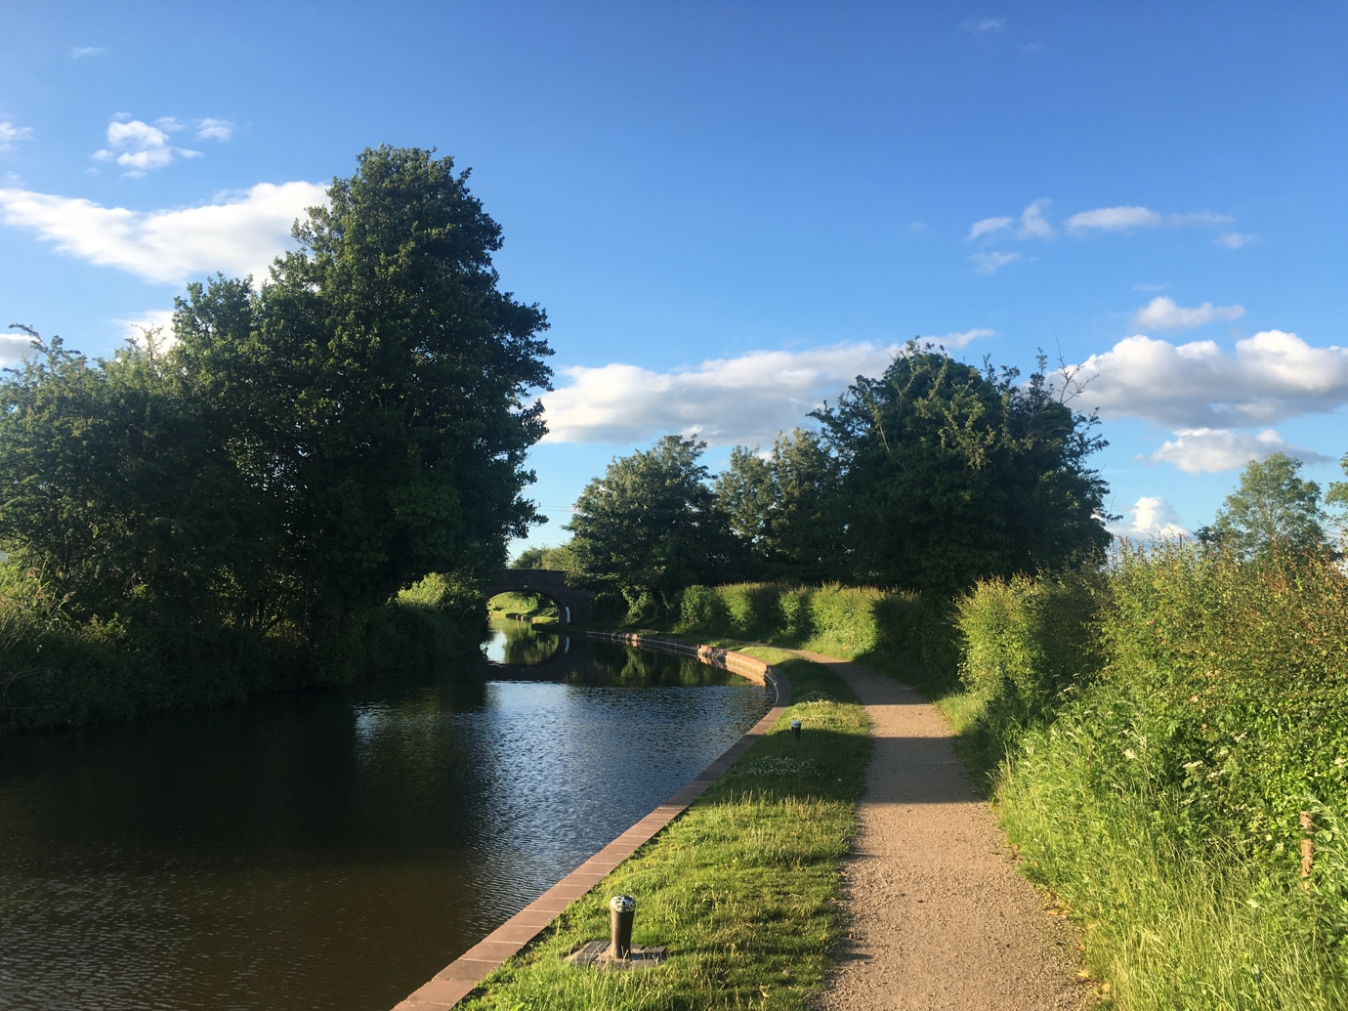
IMG_4221 Barratt Homes’ Henbrook Gardens development is located on the banks of the Worcester and Birmingham canal
With the future of social distancing, travel quarantine guidelines and job security uncertain, British resorts are bracing for a staycation stampede this summer. In fact according to luxury life magazine, The Resident, there has been 28,460 online searches for ‘staycation’ in April 2020.
There has also been a 3,350% increase in searches for ‘camping bunk beds’ and a massive 400% increase in searches for ‘camping BBQ’ and ‘camping chairs’.
Tanya Silk, Sales Director at Barratt Homes West Midlands, said: “With individuals looking for a break in the UK this summer, whether that be camping, days out or even just exploring their local area, we want to show people that staying at home for your summer holiday could actually be a great experience, so we have put together a list of suggestions for those planning to do just that.
“At all our developments we ensure we carefully select areas that offer a variety of nearby amenities and attractions for home buyers of all ages. Exploring the local area that you have just moved to can often be an exciting time and shouldn’t be overlooked as you start to plan your staycation.”
Get to know the local area
Many people don’t realise how much there actually is to do on their doorstep, especially when moving to a new area. It’s extremely important to get to know your new town or village and find out about local events and activities you can take part in.
Spend some time on your staycation looking inside all of the recently re-opened local shops that you wouldn’t normally have time to visit and take a trip to that park that you always drive past but never go to.
Local businesses are the backbone of the economy and it’s great to support your neighbours in their ventures of starting up shop. You may even be surprised about the competitive prices and the hidden gems that you find in these beautiful boutiques.
Meet the neighbours
If you think you’ll miss out on meeting the locals when going abroad, why not attend local events, online or socially distanced, in your community and meet your neighbours? Take a look on local community websites and social media to see what’s happening in your area.
New Barratt Homes developments form brand new communities that flourish from when the first residents move in – so get to know the people living next to you and become a part of this.
Host your own staycation event
Subject to guidelines, get your friends or social bubble together and host your very own socially distanced staycation event in your garden. This can include everything from a tropical theme and drinks to getting out the paddling pool and playing outdoor games or creating a homemade beach.
Try exotic foods from the comfort of your own home
On your staycation, you should still aim to try something new and have different experiences, which includes what food and drink you have. Hit your local supermarket to see what you can discover in there. Try new recipes you wouldn’t normally look at and find what you like and what you don’t from the comfort of your own home.
Don’t fancy cooking whilst you’re off? Why not look at taking advantage of a nearby takeaway?
Take a day trip somewhere exciting and try something new
Day trips always give families something to look forward to whilst enjoying their time off together. Why not plan an adventure day that everyone can enjoy nearby? Doing something together that you’ve not done before is not only a thrilling experience, but it also brings the whole family together.
Each Barratt Homes development is located nearby to a host of great transport links, meaning it’s always easy to travel further afield for a day out.
Barratt Homes are now open on an appointment only basis and are currently building homes in Worcestershire at Henbrook Gardens in Stoke Prior.
To find out more information visit www.barratthomes.co.uk/henbrookgardens call the sales line on 0333 355 8475 to book an appointment with a Sales Adviser.
The sales line is open from Monday to Friday 9am - 8pm and Saturday and Sunday 9am - 6pm. Henbrook Gardens is open Monday to Sunday 10am – 5.30pm for appointments.
A detailed set of working practices and protocols has been developed by Barratt Homes so that its construction sites can operate safely and in line with the latest guidance from Government, Public Health Authorities and the Construction Leadership Council.

ENDS
NOTES TO EDITORS

- For further information about Barratt Homes please contact Alice Warner on 0116 247 1777 / 07531499312 or alice@unsworthsugden.co.uk

- Barratt Homes is part of Barratt Developments PLC, a FTSE100 company

- Barratt was awarded a maximum five star rating for the 11th consecutive year in the 2019 Home Builders Federation Customer Satisfaction Survey

- Site managers working for Barratt Group won 92 awards for quality workmanship in the 2020 NHBC Pride in the Job Awards. Barratt has won more Pride in the Job awards than any other housebuilder for the last 15 years.

https://www.theresident.co.uk/lifestyle-london/staycation-ideas-uk-isolation-holiday/

